**EXPERIMENT 1-LED FLASHER**

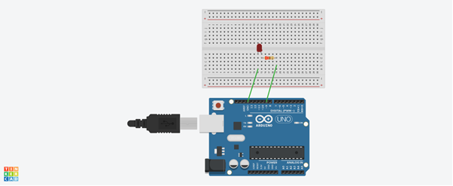

**AIM-**

The aim of the experiment below is to DESIGN AN LED FLASHER.

I will be using an Arduino Board and a breadboard to make a simple circuit, one that can turn on an LED light. Using some basic codes, I will make the same LED light blink.

**CONCEPTS USED-**

1.I have used the concept of Arduino Board; using its hardware and software.

Arduino consists of both a physical programmable circuit board (referred as microcontroller) and a piece of software or IDE (Integrated Development Environment) that runs on computer, used to write and upload computer code to the physical board.

* DIGITAL Pins: 0-13-Can be used as input or output pins
* ANALOG Pins: A0-A5-Used to provide analog input in the range of 0-5V.
* 5V-It is the regulated power supply used to power micro-controller and other components on the board
* GND-Ground Pins that acts as ground.

2. I have used the concept of p-n junction diode.

3. Use of Breadboard

Breadboard-It is a thin plastic board used to hold electronic components that are wired together. It is used to develop prototypes of electronic circuits

4.How a resistance is used in the circuit.

5.LED Flasher-The simplest LED flasher is to turn off and on an LED at fixed intervals. More complex LED flashers are found in circuits used as indicators and controllers, as well as in home built projects.

**LEARNING AND OBSERVATIONS-**

I learnt the following-

1. The concepts and working of Arduino Board

2. The working of the Breadboard.

3. Creating a circuit using Breadboard and Arduino Board.

4. All the accurate connections in a circuit.

I made the following observations-

1.The Arduino Board provided a supply of 5V to the Flasher Circuit.

2.I connected the positive terminal of the LED to the 13th Digital pin on the Arduino Board and the negative terminal to the GND pin.

After uploading the code on the Arduino software, the LED started switching on or off or blinking after an interval of 500 milliseconds.

**PROBLEMS AND TROUBLESHOOTING**

1.The LED was not glowing due to its loose connection. I took it out from the breadboard and reinserted it so that it was connected properly and not hanging loosely.

2.At first, I gave the delay of a very short time interval that is 100 milliseconds. But I noticed that the LED blinking was not much noticeable. Therefore, I increased the delay to 500 milliseconds.

**PRECAUTIONS**

The main precautions that we need to take before and while performing this experiment are as follows-

1.We need to handle all the equipment with great care whether it is the software or hardware.

2.The LED must be checked before connecting it to the circuit on the breadboard as sometimes the LED is not working properly.

3.The connections on the Arduino board must coincide with the codes written on the software on the sketch in the Void Setup section.

4.While writing the code, the insertion of delay should not be forgotten and that too of the required time interval and not any random value.

5.In the sketch, the instructions should be given only in the void loop section.

**LEARNING OUTCOMES**

While performing the experiment, I learnt various concepts and skills-

1.I have learnt to make circuits using a breadboard, Arduino Board and other equipment and handle the different hardware.

2.I observed the various patterns of LED flashing by changing the value of delay in milliseconds.